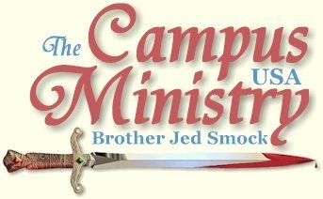
BROJED.ORG
brojed@aol.com
Cell: 573-999-0346
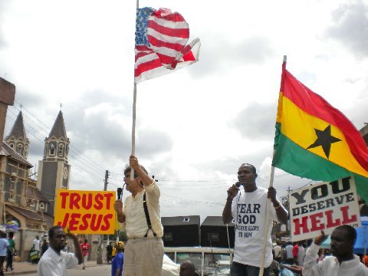
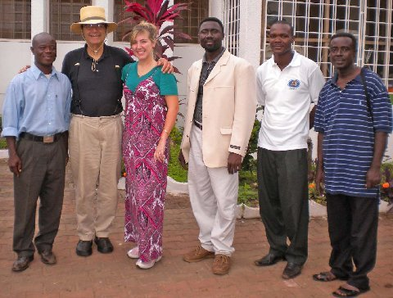
The Traveling Team: Simon, Bro. Jed, Charlotte, Bro. Francis, Peter

Eldad and Medad
August 15, 2009, Attendance was considerably down this morning with only about 20 students; but I was not discouraged, God is able to save by many or by a few. Each session Charlotte has played her flute before my teaching. It touches my heart since I have not heard her play the flute in a few years. The people also receive Charlotte warmly.
I opened by teaching on the three men who would not pay the cost of true discipleship (Luke 9). I reminded the student that the fields were ripe for the harvest (John 4:35). Since I coved many of the basics yesterday of what Jesus taught concerning rekindling the spirit of evangelism. This morning I concentrated on the Acts of the Holy Spirit and the apostles to rekindle this spirit. I covered high lights of the first four chapters of Acts. I spoke on the whole armor of God. Then I went back to Moses for instructions and how he dealt with Eldad and Medad two men who had not been ordained elders but prophesied among the people to the envy of the elders, including Joshua. When the elders attempted to get Moses to stop them, Moses answered, “Enviest thou for my sake? I would God that all the LORD’S people were prophets, and that the LORD would put his Spirit upon them!”
Moses’ prayer was answered on the day of Pentecost when the 120 were filled with the Holy Ghost in the upper room. Paul prayed similar to Moses when Agrippa was almost persuaded to become a Christian, Paul said, “I would to God, that not only you, Agrippa, but also all that hear me this day, were both almost, and altogether such as I am, except these bonds (Acts 26:29).” I reminded the students that God would make us all prophets if we are willing to pay the cost and suffer with Christ. I challenged them to aspire to be as great for God as St. Paul. I concluded the service by leading the students in the prayer for boldness to speak God’s word (Acts 4:29-31). And I laid hands on each and prayed for them to receive a baptism of boldness and even prophesied over several.
After presenting the certificates, we had a time of refreshment. Today we drove to the market with the students and the pastors holding signs, my crucifix staff and singing. I preached a basic message addressing issues of sin, righteous, and judgment from the bed of the pick-up truck with Peter interpreting. Afterwards we moved through the crowd. My students witnessed one on one or talked to small groups. I was asked to pray for about 20 for salvation. The young ones I led in “Jesus Loves Me” and the “B-I-B-L-E” songs. After leading the older ones in a sinner’s prayed, I led them in singing, “I have decided to follow Jesus.” My diciples were leading people to the Lord. We may have had about 40 decisions for Christ within an hour. Brother Pius, national director of the Bible League, prayed with a group. He reported that one fellow, who was cutting coconut, confessed to fornication. Another coconut cutter admitted that he was a fornicator and wanted Bro Pius’ cell phone number in order to call him later. On our way back to the hotel the fornicating coconut cutter called Brother Pius; so it looks like he will be able to do follow up work.
I considered today to be our best day yet in the market place. It may have been to our advantage that we were not allowed to use the amplification. I have found that a microphone and amplification can be a barrier between the speaker and the people. And the speaker has a tendency to rely too heavily on the amplification. Sudents boldly moved from individual to individual or group to group calling people to repentance and faith. I thought the Holy Spirit knit us together as a team.
“It came to pass, when Jesus had made an end of commanding his twelve disciples, he departed thence to teach and to preach in other cities (Matt 11:1).” I have taught my 20 disciples for three days; tomorrow I depart to another city for my concluding seminar on evangelism in Ghana. The students in the Nsawam class are committed to continuing in the Word and being disciples indeed.
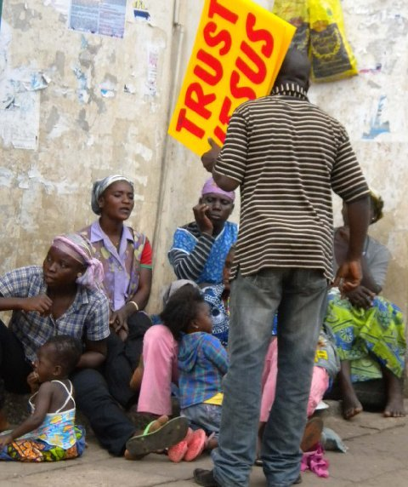

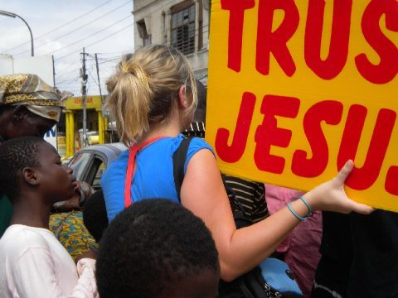
“Such Is Missionary Life”
August 16, 2009, we left our hotel in Nsawam for Kumasi which was over a three hour drive in a 12 passenger van. There were six Moslem men in the back. Brother Francis asked to pray and he petitioned the Father, Son, and the Holy Ghost. Afterwards, he told the Moslems that life was meaningless without Jesus Christ.
We arrived at the church just after the Pastor dismissed the congregation. However, when he saw us coming, he called the church back into session. Charlotte and I were introduced. I gave a 10 minute introduction of my ministry and expectations for the seminar and workshops. Charlotte played “Amazing Grace.” Brother Francis briefly exhorted the congregation concerning taking to gospel to the open-air. Pastor once again dismissed the congregation and drove us to his home for dinner. I was very tired and fell asleep on the couch. I would rather have had gone right to our lodging. We ate after about 90 minutes. The food was good, rice with an excellent tomato sauce and avocado. The salad look good; but we have been advised not to eat the salads.
I met Pasha, who is an interesting character. He had a copy of Who Will Rise Up?, which Barry Groves of Faith Tech ministry had given him in 1997. It was well underlined. He told me that he had read the book many times. He showed me the Smock family pictures in the book which he appreciated. He wanted me to point out which one was Charlotte as a little girl. He then showed me a Bible which he had purchased in 1998 which he dedicated to confrontational evangelism and his “mentor,” Jed Smock. He made several references to my book throughout our time of fellowship. He examined my crucifix walking stick. He is determined to have one made for himself by a carpenter friend. Pasha, who was a jockey as a boy, plans on purchasing a horse from the northern part of the country and ride and witness in southern Ghana where horses are unusual. Pasha has a gregarious personality and is very articulate.
They took us to our lodging, which was in Sam’s home who is an associate in the church we are working with. Charlotte and I each have had our own hotel rooms which have been pleasant. However, in this home we were given one small cluttered room with bad ventilation and no ceiling fan. Charlotte and I looked at one another and thought we would have to make the best of it for the next four nights. However, within 30 minutes Brother Francis called to say he had secured a hotel room for us. He apologetically said that the room in the home was two small. As we were driving away all the men were apologizing and the Pastor Asaymoah said, “Such is missionary life.”
We checked in a large, clean and comfortable room which Charlotte and I will be sharing. The Lord is taking good care of us.
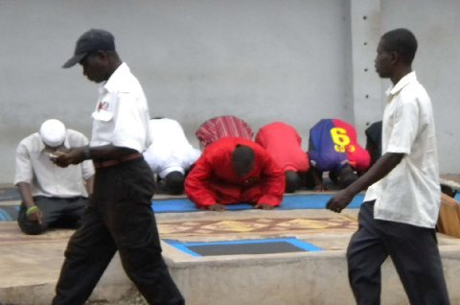
Moslems Praying
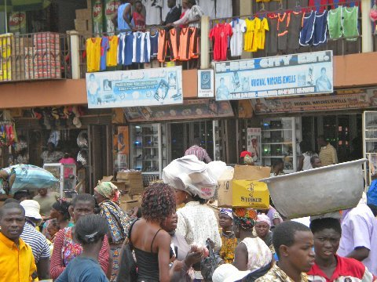
Brother Jed the Observer
August 17, 2009, the third seminar opened at Pastor Asaymoah’s church which is in a small clearing in the middle of a field as thick with foliage as a jungle. The church is a slab of concrete with a metal roof. At each seminar I am going over some of the same basics; but I also introduce new material at each seminar for the benefit of the team of pastors who are travelling with me. This morning I taught and preached from Acts 17. In Athens Paul confronts the philosophers, Jerusalem confronts Athens, the wisdom of God confronts vain philosophy, the Jew confronts the Greek, the Christian confronts the pagan, religion confronts humanism, and faith confronts agnosticism (the unknown God). Paul was unashamed of the gospel. Today, I fear that Jerusalem is intimated by Athens. Paul’s spirit was stirred in him at Athens. I remarked, “If we are going to rekindle the spirit of evangelism in Ghana then Jerusalem needs to confront Athens once again. We need to know that the wisdom of this world is foolishness with God. It pleases God by the foolishness of preaching to save them that believe.”
In many ways Ghana is blessed because it has not been overly influenced by the Greeks. Jerusalem is respected. Nor has Ghana gone the way of Babylon and Egypt as the West has been doing over the last generation by rejecting the thoughts of dead white men. As we drove through the streets of Kumasi, I noticed two young students each carrying a heavy volume of “The Works of William Shakespeare.”
This afternoon Pasha led the way into the paved streets of the city center. I was designated an observer. Evidently the pastors were concerned about conserving my strength. I followed the Christian march through the main business district of the city. The preachers used bull horns with no restrictions. Virtually, all the students who went with us preached and were active in witnessing one on one or testifying to small groups.
The stores were more sophisticated than the dirt streets where we have been evangelizing. However, the goods still seemed below the quality of the Dollar Store.
The people of Ghana seem well nourished. Fresh fruit and vegetables are plentiful. Chickens and goats freely roam the streets. We have seen no children with bloated bellies and flies in their faces. The people appear to be strong and happy.
In the evening we visited Rev. Dr. Asafo-Agyei at the hospital which he established. He may be the Oral Roberts of Ghana for he also pastors a church and has established a theological school. He was chosen as one of 2000 outstanding scientists of the 20th Century. He is internationally known for his successful non-surgical treatment of piles or hemorrhoids. His heart is for the gospel and souls. He uses his hospital to reach people’s souls through ministering to their sick bodies. He told of his success of getting Moslems saved as a result of them seeking him for medical treatment. Brother Francis arranged for this visit for Charlotte’s sake. He will be a good contact for a future return of Charlotte to Ghana to do medical missions and work in the hospital for a few weeks.
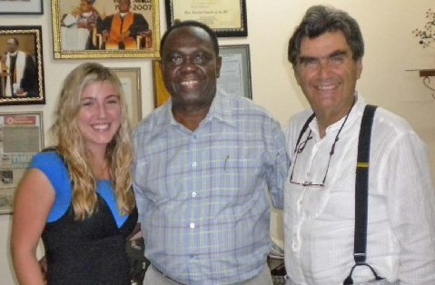
Rev. Dr. Asafo-Agy
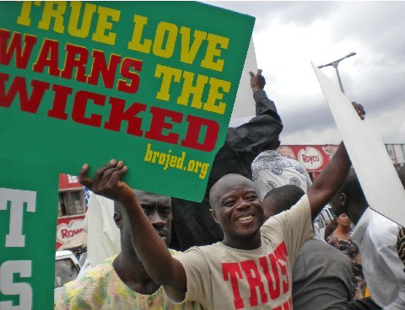
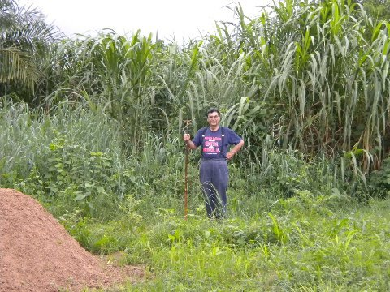
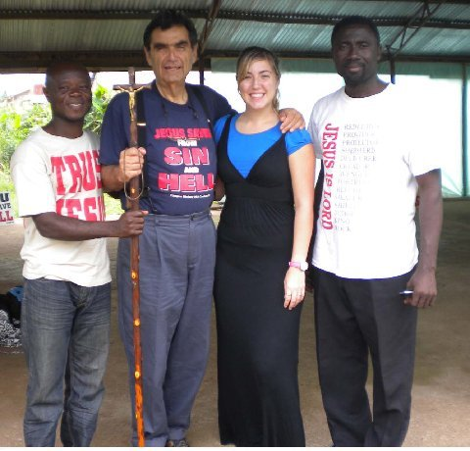

“Does Anyone Know What Time It Is?”
August 18, 2009, “Does anyone know what time it is? Does anyone really care?” These lyrics from the rock group Chicago back in the sixties have been ringing in my ears daily. Our seminars are supposed to be from 9-12 AM. My driver typically picks me up at 8:30 AM. Then we have a leisurely breakfast. The last two days it consisted of the best porridge that I have ever consumed. Yesterday, it included Swedish type pancakes and of course always fresh fruit. We arrive at the church about 10:15. Already, numbers have gathered and they have been praying (mostly in tongues), praising the Lord and singing. This continues for another fifteen minutes. Finally, I am introduced. I usually teach for 90 minutes. I am adjusting but it is difficult because I practice punctuality.
This morning I explained how confrontational evangelism worked in my own life. Principally through Holy Hubert, the apparent Arab dressed traditionally (possible angel?) on the beaches of Morocco, and my old high school chum, Clyde Swalls on the streets of Terre Haute, IN. I also addressed the subject of apologetics from 1 Peter 3:15. “Apologetics is the science and art of defending Christianities basic truth claims.” I explained how many professors have mastered the science; but fail in the art of apologetics. My staff crucifix, the gospel signs and t-shirts, the energetic and dramatic style of teaching and preaching, and my satire are part of the art of apologetics. I explained that we should employ all the arts in order to get our message across. We cannot afford to be boring if we are going to rekindle the spirit of evangelism in Ghana.
In the afternoon we drove though some of the tightest traffic which I have ever experienced. We mounted amplifiers on top of the cab of Pastor’s pick up, which his children have dubbed “the hummer.” I rode in the cab, Pastor Asaymoah drove, and Charlotte and two pastors were in the back seat. My disciples preached all the way to our preaching sight from the bed of “the hummer.” They were mostly speaking in the native tongue, Tri. They must have been doing well because someone threw mango at us, which splattered all over the windshield, the top of the cab and upon several of the men. Our destination was Roman Hill. A Roman Catholic Church built in the early 20th Century called St. Peter’s Cathedral sits at the top of the hill. It is the most beautiful of the churches that I have seen in Ghana. One thing about the Catholics they know how to build Cathedrals. The market as always was teeming with people. The students and pastors preached and some of the students moved through the crowd witnessing. Finally, my translator, Peter, asked if I wanted to preach. It is not my nature to be an observer like yesterday. So I jumped up on the bed of the truck took the mike in one hand and a large American flag in my other. Peter held a mike and the flag of Ghana.
I emphasized John 14:6 warning the crowd that all Muslims, Hindus, Buddhists, Messiah denying Jews, skeptics, agnostics and atheists go to Hell. I warned that professing Christians who practiced sin (hypocrites) go to Hell. I cried out against drunkenness, unlawful drugs, and witchcraft. I preached salvation through the cross. I led our team and the students in the song, “I Have Decided to Follow Jesus.” Finally, I gave an altar call. The altar was the bed of the truck. Initially, a few children responded and I prayed for each of them. Next adults came forward. One confessed to fornication, and another to being a drunkard, and another to being a backslider. I led each of them in a prayer of repentance. More came forward for prayer for healing who claimed to be living holy lives. I prayed a healing prayer over each one. It was hot and humid. People kept coming forward to ask for prayer. Finally, Peter, wisely said, “Brother Jed, you cannot pray for all these people. Pray a general prayer.” I announced if you are here for the salvation of your soul from sin and death, raise your hand. A number raised their hand and I led them in a sinner’s prayer. Next, I asked, “Who needs healing in your body?” For those who raised their hand I led them in a prayer for healing.
Three wretched looking ladies each gave me a widow’s might. I mean wretched in the sense of poverty stricken, not spiritually. Despite the poverty, I notice a dignity in the women which I respect. Carrying their pans and stuff upon their heads gives these women good posture. I have seen more bare breasts than in the U.S. However, these bare breasts have a sucking baby. They are not flaunting silicone enlarged breast for the enticement of lecherous men, nor are they aborting their offspring. I have notice one small family planning sigh while in Ghana. I gladly and thankfully received the mites from these women poor in material goods but rich towards God.
“The Hummer”
Charlotte helped me to the cab of “the hummer” since I needed a break from the swarms of seekers whose needs were so great. I needed a moment of rest to renew my strength. After people left the truck, Pasha took me on a tour of St. Peter’s Cathedral. As we entered the church a banner asked, “What shall I render unto the LORD for all his benefits toward me (Psalm 116:12)?” We examined and commented upon each picture in the Cathedral which depicted the Stations of the Cross. When we walked out of the building, I lifted my voice and briefly answered the question posed by the banner as to what we should render to the Lord, our lives, our obedience and our witness. Someone in authority asked Pasha what we were doing. Evidently, we were not supposed to take pictures without permission. Peter, who was taking the pictures, thought they were offended by the “You Deserve Hell” sign which Pasha was holding. I suspected that it was my brief exhortation. Pasha handled the situation graciously and wisely. He asked forgiveness for any offense several times. I affirmed his request. The authority nodded his head and we departed the grounds.
The preachers were still preaching and witnessing on Roman Hill. Shortly after 3 PM we wrapped things up and drove back to Pastor’s home for dinner. As we slowly drove through the streets the pastors and students were singing. We reached countless people today. One can reach more people on a regular day on the streets of the cities of Ghana than at the Rose Bowl parade or the Super Bowl. Ghana is heaven for a street preacher. The streets, however, are not paved with gold; many of the streets are not paved with anything but the teeming masses, readymade crowds for any Christian who is willing to sound the trumpet. After dinner the Pastor at my request, took us back to our hotel. Charlotte commented on the way to our room, “This has probably been our hardest day.” I agreed; but it may prove in eternity to be our most productive day.
Last night we went to sleep with loud African music just down the street from the Aknac Lodge Hotel. I awoke at 6 AM to the same music. It must have gone on all night. Charlotte suggested that there must be a bar down the street. When the Pastor picked us up I asked him about the music, he pointed out that it was coming from a walled home down the street where there was a three night and day wake going on for a young person who had died. As I write in my journal about 6 PM, the music is still loudly playing.
Another song from my boyhood has been ringing in my ears for several days, “When we all get together, together, together, when we all get together, how happy we will be. For your friends are my friends, and my friends are your friends, when we all get together how happy we will be.”
Togetherness is a cultural phenomenon in this country and especially with the team of pastors who are hosting me. Everything is definitely a group activity. I have always been somewhat of a Lone Ranger. I have been on the road for almost four decades mostly travelling alone. Loneness seems unknown in Ghana, where the ideal seems to be the more the merrier. People of Ghana have little concept of privacy which we Americans tend to value. Although Pastor Asaymoah and some of the people live in homes behind a wall, extended members of the family are regularly present. I have a tendency to wander from the group wherever I am. Twice Charlotte and I have gone off exploring and we do not get a block away before someone in the team of Pastors, usually Simon, comes running after us to aggressively bring us back to the group. Charlotte and I have learned our lesson.
This evening I Pastor Asaymoah was to drive us to an internet station. But along the way we got into traffic that had come to a complete stop, evidently something or somebody was blocking the road. There are no or few police around to do anything about the situation. So Pastor drove on some back street to get around the stoppage, only to get into another jam where traffic was at a virtual standstill. Pastor decided to give up on the internet station and go home. To get out of the traffic we drove over roads which I would have considered impassable; but not too much for “the hummer.” These people are not deterred by the condition of the road so we were able to finally get back on a paved street out of the traffic jam. On the way Pastor urged us to come back to his house which is only a several blocks from the hotel. I protested that we wanted to go back to the hotel. Pastor’s son, who is a college student and very pleasant and intelligent and articulate said, “No, we need to go back to the house and have fun. My mother is home now.” I insisted on the hotel. I have learned that if I am going to conserve my strength to minister I have to restrict the socializing. Charlotte and I were concerned that we might have offended them. They are so nice, accommodating and hospitable; but there is just so much togetherness that I can abide and at the same time keep up with my journal have time in the Word and prayer, and conserve my strength. I was impressed that the boy thought that his mother would add to the fun. There is one other problem with the socializing, which is understanding the accent of the hosts. One has to be especially alert, which is difficult after a long day of ministry.
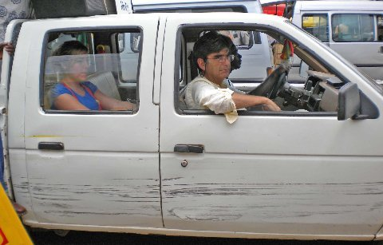
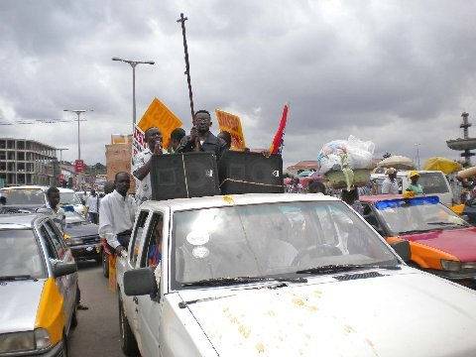
The Hummer
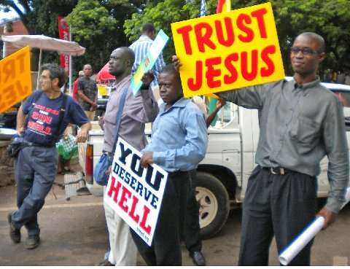
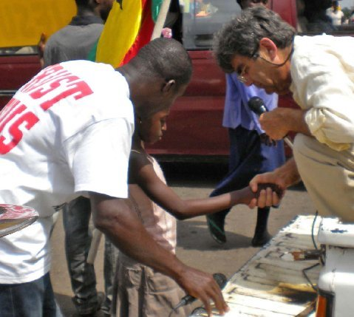
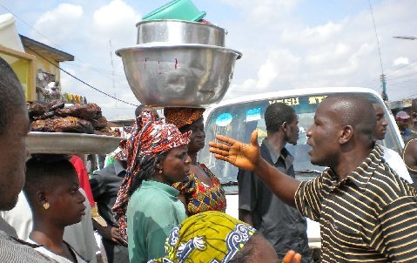

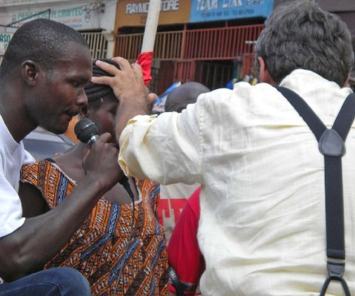
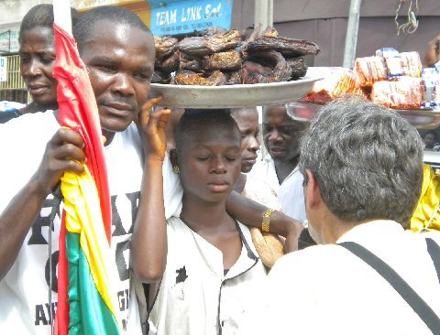
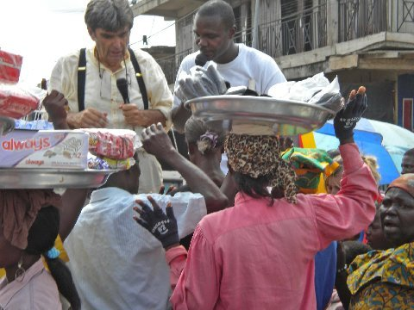
Prayers for Salvation

